**C1 Eventing On The Flat Checklist 2023**

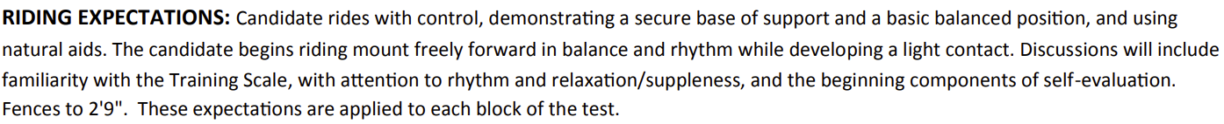Checklist is divided into On the Flat and Over Fences sections. A few boxes may be repeated on both pages if candidate is taking both sections of the test at the same time. Instructor should only sign when the candidate can consistently perform the “Riding Expectations” while performing the skills in each box.

|  |  |
| --- | --- |
| Topic | Sign and Date |
| • Demonstrate mount’s warm-up routine for everyday work.  • Discuss candidate’s warm-up and mount’s warm-up in relation to rhythm and relaxation/suppleness, using terms and understanding of the Training Scale. |  |
| • Discuss candidate’s position and its influence on horse’s balance, rhythm, and suppleness. |  |
| • Perform figure eights with simple transitions at each gait and demonstrating correct bend. |  |
| • Demonstrate long rein, loose rein and light contact at walk.  • Demonstrate a step back of 1-2 steps.  • Discuss aids for and demonstrate a turn on the forehand. |  |
| • Ride without stirrups at the sitting trot and rising trot. |  |
| • Ride USEF Beginner Novice Test A. |  |
| • Discuss dressage test performance, including the rider’s application of the Riding Expectations. |  |
| • Rider shows firm basic balanced position while using natural aids and in control. The rider begins riding mount freely forward while developing a light contact. |  |
| • Ride safely with control in a group, on a suitable mount, at the walk, trot and canter over varied terrain. |  |
| • Discuss and demonstrate riding safely over varied terrain, incorporating as many of the following elements as local conditions allow: hills, flat open areas, and shallow streams as available. |  |
| • Discuss performance with Examiner.  • Rider shows firm basic balanced position while riding with control. |  |

**C1 Eventing Over Fences Checklist 2023**

Checklist is divided into On the Flat and Over Fences sections. A few boxes may be repeated on both pages if candidate is taking both sections of the test at the same time. Instructor should only sign when the candidate can consistently perform the “Riding Expectations” while performing the skills in each box.

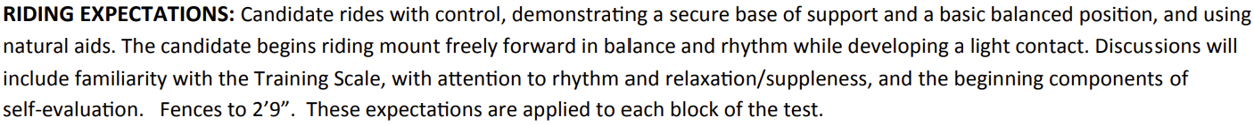

|  |  |
| --- | --- |
| Topic | Sign and Date |
| • Demonstrate mount’s warm-up routine for jumping.  • Discuss candidate’s warm-up and mount’s warm-up in relation to rhythm and relaxation/suppleness, using terms and understanding of the Training Scale. |  |
| • Ride without stirrups at the sitting trot.  • Discuss candidate’s position and its influence on horse’s balance, rhythm, and suppleness. |  |
| • Ride over small gymnastic grid of trot poles to 3 fences, finishing with an ascending oxer set at, but not exceeding, 2’9”. Grid and trot poles to be set at appropriate distances for mount’s stride. |  |
| • Ride over a course of 6-8 obstacles in an enclosed area that includes a two-stride combination set at an appropriate distance for mount’s stride. The majority of fences should be set at, but not exceeding, 2’9”. |  |
| • Discuss performance, including balance and rhythm, and ways ride could be improved. |  |
| • Ride safely with control in a group, on a suitable mount, at the walk, trot, and canter over varied terrain.  • Discuss and demonstrate riding safely over varied terrain, incorporating as many of the following elements as local conditions allow: hills, small/shallow ditches, low banks, flat open areas and shallow streams. |  |
| • Ride over 5-7 cross-country obstacles at appropriate speed (240-350 mpm), connecting fences as a course. The majority of fences set at, 2’6” - 2’9” but not exceeding, 2’9”. |  |
| • Rider demonstrates a secure base of support and control over course.  • Discuss performance, pace, and reasons for any disobediences. |  |